The Pentium family of processors originated from the 80486 microprocessor. The term ''Pentium processor'' refers to a family of microprocessors that share a common architecture and instruction set. It runs at a clock frequency of either 60 or 66 MHz and has 3.1 million transistors. Some of the features of Pentium architecture are:

* Complex Instruction Set Computer (CISC) architecture with Reduced Instruction Set Computer (RISC) performance.
* 64-Bit Bus
* Upward code compatibility.
* Pentium processor uses Superscalar architecture and hence can issue multiple instructions per cycle.
* Multiple Instruction Issue (MII) capability.
* Pentium processor executes instructions in five stages. This staging, or pipelining, allows the processor to overlap multiple instructions so that it takes less time to execute two instructions in a row.
* The Pentium processor fetches the branch target instruction before it executes the branch instruction.
* The Pentium processor has two separate 8-kilobyte (KB) caches on chip, one for instructions and one for data. It allows the Pentium processor to fetch data and instructions from the cache simultaneously.
* When data is modified, only the data in the cache is changed. Memory data is changed only when the Pentium processor replaces the modified data in the cache with a different set of data
* The Pentium processor has been optimized to run critical instructions in fewer clock cycles than the 80486 processor.

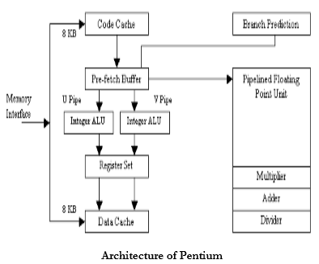

The Pentium processor has two primary operating modes -

1. Protected Mode - In this mode all instructions and architectural features are available, providing the highest performance and capability. This is the recommended mode that all new applications and operating systems should target.
2. Real-Address Mode - This mode provides the programming environment of the Intel 8086 processor, with a few extensions. Reset initialization places the processor in real mode where, with a single instruction, it can switch to protected mode.

The Pentium's basic integer pipeline is five stages long, with the stages broken down as follows:

1. Pre-fetch/Fetch: Instructions are fetched from the instruction cache and aligned in pre-fetch buffers for decoding.
2. Decode1: Instructions are decoded into the Pentium's internal instruction format. Branch prediction also takes place at this stage.
3. Decode2: Same as above, and microcode ROM kicks in here, if necessary. Also, address computations take place at this stage.
4. Execute: The integer hardware executes the instruction.
5. Write-back: The results of the computation are written back to the register file.

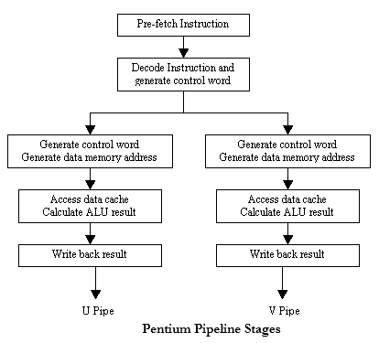

**Pentium Superscalar Architecture**

Compared to pipelining, a more aggressive approach is to equip the processor with multiple processing units to handle several instructions in parallel in each processing stage. With this arrangement, several instructions start execution in the same clock cycle and the process is said to use multiple issue. Such processors are capable of achieving an instruction execution throughput of more than one instruction per cycle. They are known as ‘***Superscalar Processors’***.

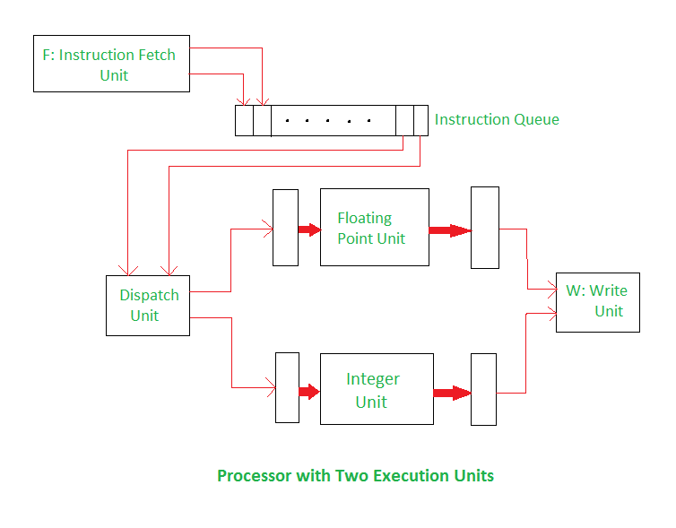

In the above diagram, there is a processor with two execution units; one for integer and one for floating point operations. The instruction fetch unit is capable of reading the instructions at a time and storing them in the instruction queue. In each cycle, the dispatch unit retrieves and decodes up to two instructions from the front of the queue. If there is one integer, one floating point instruction and no hazards, both the instructions are dispatched in the same clock cycle.

**Advantages of Superscalar Architecture:**

* The compiler can avoid many hazards through judicious selection and ordering of instructions.
* The compiler should strive to interleave floating point and integer instructions. This would enable the dispatch unit to keep both the integer and floating point units busy most of the time.
* In general, high performance is achieved if the compiler is able to arrange program instructions to take maximum advantage of the available hardware units.

**Disadvantages of Superscalar Architecture:**

* In a Superscalar Processor, the detrimental effect on performance of various hazards becomes even more pronounced.
* Due to this type of architecture, problem in scheduling can occur.